Tim Van Laere Gallery
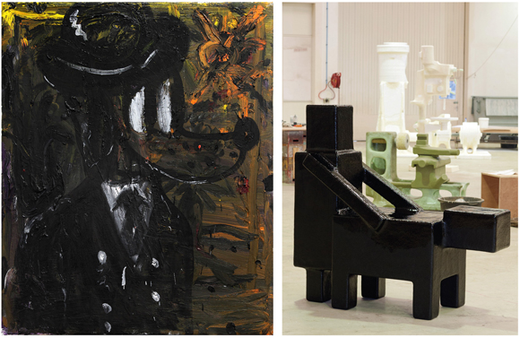
Left: Armen Eloyan, Black dog, 2013. Oil on canvas, 110 x 90 cm. Courtesy Tim Van Laere Gallery, Antwerp. Right: Atelier Van Lieshout, Domestication, 2013. Fibreglass, 175 x 80 x 160 cm. Courtesy Tim Van Laere Gallery, Antwerp.

Armen Eloyan
Corn in your fruity basket
Atelier Van Lieshout at Tim Van Laere Gallery

Untill 25 January 2014
Tim Van Laere Gallery
Verlatstraat 23-25, 2000 Antwerp, Belgium
T +32 3 257 14 17
F +32 3 257 14 25
info@timvanlaeregallery.com
www.timvanlaeregallery.com
Tim Van Laere Gallery is pleased to announce Corn in your fruity basket, the second solo exhibition of Armenian-born artist Armen Eloyan at the gallery.
The instinctive approach Eloyan applies to his painting draws on his emotional bond to an array of collective experiences, related to childhood and youth. The artist's attitude of painting even refers to the automatic painting of the New York school (Hans Hofmann, Willem de Kooning). Most of the titles here such as Black dog or Dizzy girl seem to be fairly unmistakeable, when iconic figures as Mickey Mouse, dogs and dinosaurs reappear in his work. Eloyan frequently uses oil paint as a sculptural material, applying it to his canvases layer by layer, resulting in virtually three-dimensional objects. The physicality of the paint and the emphasis on the fact that they are manually done seem to be the key to understanding them.
Corn in your fruity basket is an exhibition imbued with Eloyan's intuitive relationship to painting and is infused with a desire to express pure fun and joy mixed with dark humour.
Armen Eloyan (b. 1966, Yerevan, Armenia) lives and works in Zurich, Switzerland. Recent solo exhibitions have included Galerie Bob van Orsouw, Zurich; Timothy Taylor Gallery, London; Kunst Halle Sankt Gallen, St Gallen; Centre Culturel Suisse, Paris; and Parasol Unit Foundation for Contemporary Art, London. Group exhibitions include A Vision of Central Europe, curated by Luc Tuymans, Bruges; Until the End of the World, AMP Gallery, Athens; Ventriloquist, curated by Emma Dexter, Timothy Taylor Gallery, London; and INVOLVED, curated by Philippe Pirotte, ShanghART Gallery & H Space, Shanghai.
Since sculpture is one of the main focuses of the Tim Van Laere Gallery,Domestication, a new sculpture by Atelier Van Lieshout will be shown in the Tim Van Laere Gallery_Yard, an outdoor space next to the gallery.
Joep van Lieshout lives and works in Rotterdam. Since the early eighties, he has produced objects in mainly bright-coloured polyester, the material that would become his trademark in subsequent years. In 1995 he founded Atelier Van Lieshout (AVL), undermining the myth of the individual artistic genius. Atelier Van Lieshout has attained international recognition for objects that balance on the boundary between art, architecture and design. These works of art are practical, uncomplicated and substantial. Recurring themes in the work of AVL are autarky, power, politics and the more classical themes of life and death.
Works of AVL can be found in many important private collections and several international museums such as Museum Boijmans Van Beuningen, Rotterdam; Stedelijk Museum, Amsterdam; Van Abbemuseum, Eindhoven; Bonnefantenmuseum, Maastricht; Museum Kröller Müller, Otterlo; Centre Pompidou, Paris; MoMA, New York; Walker Art Center, Minneapolis; MAK, Vienna; Ludwig Forum, Aachen; K20 K21 Kunstsammlung Nordrhein Westfalen, Dusseldorf; The Henry Moore Institute, Leeds; Sprengel Museum Hannover; and Prada Foundation, Milan.

